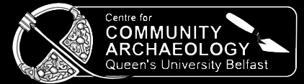

DISCOVERY 2017!
INAUGURAL ANNUAL REVIEW OF
ARCHAEOLOGY IN ULSTER

Friday 20th and Saturday 21st October 2017

Organised by the Ulster Archaeological Society and the Centre for Community Archaeology at Queen’s University Belfast

Venue: Elmwood Building, Queen’s University Belfast

Registration: Friday 20th, 5.30pm-6.30pm; Saturday 21st, 9.00am-9.30am
…………………………………………………………………………………………..

BOOKING FORM
Name …………………………………………………………………………………..

Address ………………………………………………………………………………..

E-mail………………………………………………………………………………….

Contact phone number ………………………………………………………………

Number of adults @ £20 per person …………

Number of students @ £10 per person …………

Total amount submitted £……………

Payment is by sterling cheque, payable to The Ulster Archaeological Society, or cash at the venue. Please send this booking form and remittance to the UAS Treasurer: Mr Lee Gordon, 135 Old Holywood Road, Belfast, BT4 2HQ to arrive before 18th October 2017.

N.B. Please note that fees will be refunded only if the event is cancelled due to circumstances beyond our control. Tickets will not be issued - advance booking is highly recommended, as there are only a limited number of seats available.

UAS is registered with The Charity Commission for Northern Ireland NIC 101151

